# Search Function

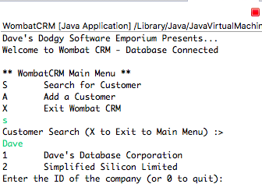

This is the search function that searches both the company name and person name fields. In this case it searched for Dave. Below is a screenshot of the table itself. This proves the search worked as intended.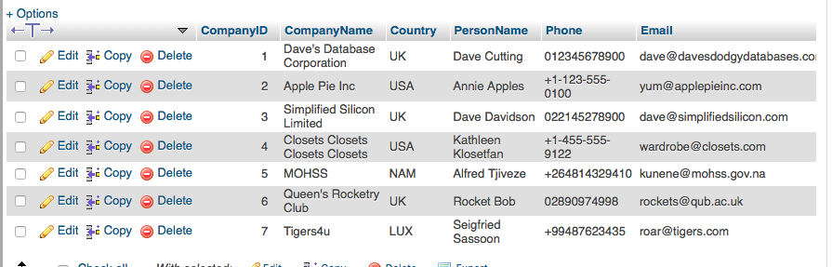

# Visible Contacts

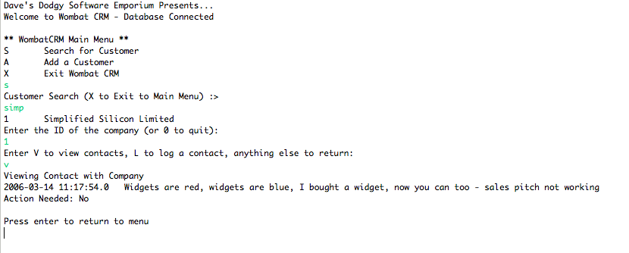

This search is showing the visible contacts for Simplified Silicon Limited. The query below shows all of the contacts associated with Simplified Silicon Limited, this shows that the java code works.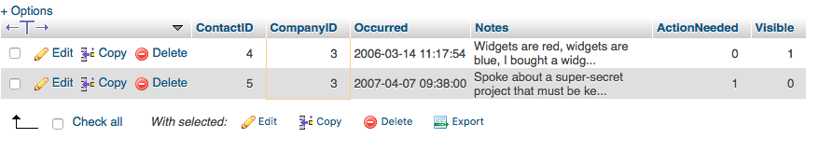

# Logged as Visible

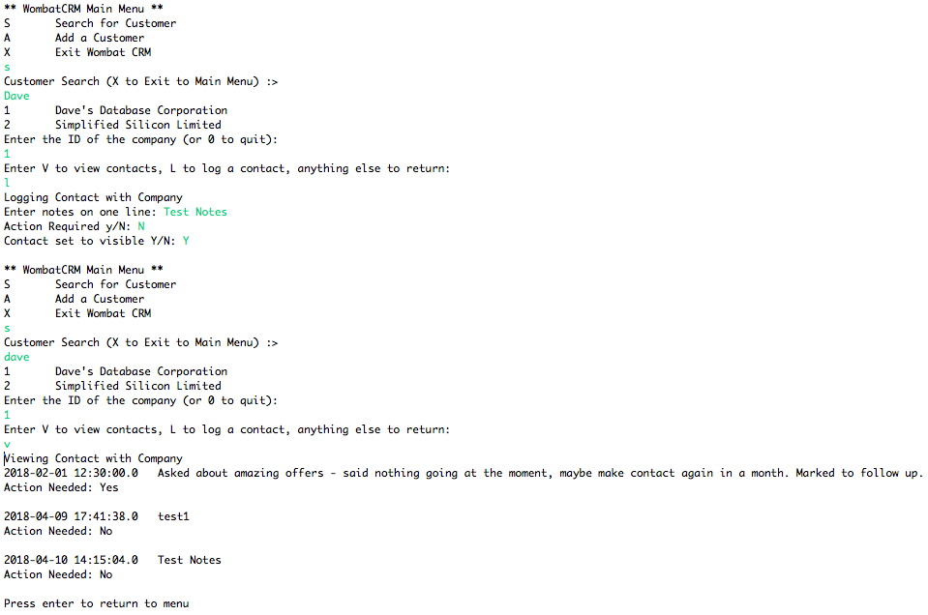

This screenshot shows that now you are able to set new contacts visibility. The above screenshot shows when you set a new contact to visible and the screenshot below shows what happens when you set it to not visible.

